# 5m Questions

## Difference between product dominant logic and service dominant logic

|  |  |  |
| --- | --- | --- |
|  | **Product Dominant Logic (PDL)** | **Service Dominant Logic (SDL)** |
| **Perspective on value creation** | One-way process where businesses create value through products and customers consume that value | Collaborative process where businesses and customers co-create value through interactions and experiences |
| **Focus** | Tangible features and benefits of products | Intangible aspects of services and experiences such as customer service, customization, and personalization |
| **Relationship orientation** | Transaction-oriented; businesses focused on selling products to customers | Relationship-oriented; businesses focused on building long-term relationships with customers |
| **Value proposition** | Emphasizes the value of the product itself | Emphasizes the value of the overall experience, which may include products, services, and other factors |
| **Customer involvement** | Passive recipients of the value offered by products | Active participants in the co-creation of value with businesses |
| **Competitive advantage** | Differentiation based on product quality, features, and performance | Differentiation based on the ability to offer personalized solutions and ongoing support |
| **Marketing focus** | Product design, production, and promotion | Understanding customer needs, preferences, and behaviours, and building relationships based on mutual value |
| **Examples** | Automobiles, electronics, packaged goods | Healthcare, consulting, hospitality, financial services |

## Types of Service Innovation

1. Process innovation: This type of innovation involves improving the efficiency and effectiveness of the service delivery process. Examples of process innovation in services include the use of technology to automate tasks, the implementation of lean management practices to reduce waste and increase productivity, and the re-design of service delivery systems to improve customer experience.
2. Service platform innovation: This type of innovation involves creating a platform that allows customers to access and customize a range of services. Examples of service platform innovation include online marketplaces, mobile apps that allow users to book and manage services, and subscription-based services that provide access to a range of products and services.
3. Service design innovation: This type of innovation involves re-designing the service experience to make it more customer-centric and personalized. Examples of service design innovation include the use of customer journey maps to identify pain points and opportunities for improvement, the creation of service prototypes to test and refine service concepts, and the development of service blueprints to ensure consistency and quality.
4. Service product innovation: This type of innovation involves creating new services or modifying existing services to better meet customer needs. Examples of service product innovation include the introduction of new services such as virtual consultations, the modification of existing services to include new features or capabilities, and the development of service bundles that combine multiple services into a single package.
5. Business model innovation: This type of innovation involves changing the way a company delivers and monetizes its services. Examples of business model innovation in services include the use of subscription-based pricing models, the creation of new revenue streams through partnerships or licensing agreements, and the development of new distribution channels to reach new customer segments.

## Features of a service provider and its criteria

Features of a service provider refer to the characteristics or qualities that a company or individual possesses in order to deliver high-quality services. Here are some of the key features of a service provider:

1. Expertise: A service provider should possess the necessary knowledge, skills, and experience to deliver the service effectively.
2. Reliability: A service provider should be dependable and consistently deliver the service as promised.
3. Responsiveness: A service provider should be able to respond promptly to customer needs and requests.
4. Empathy: A service provider should be able to understand and relate to the customer's perspective, and show empathy towards their needs and concerns.
5. Communication: A service provider should have strong communication skills to effectively convey information, listen to customer feedback, and manage expectations.
6. Professionalism: A service provider should conduct themselves in a professional manner, adhering to ethical standards and demonstrating a commitment to quality and customer satisfaction.

Criteria for evaluating a service provider may vary depending on the specific service being provided and the industry in which the service provider operates. Here are some common criteria for evaluating a service provider:

1. Quality of service: How well does the service provider deliver the service, and does it meet or exceed customer expectations?
2. Customer satisfaction: How satisfied are customers with the service provider's performance, and how likely are they to recommend the service to others?
3. Responsiveness: How quickly and effectively does the service provider respond to customer needs and requests?
4. Expertise: Does the service provider possess the necessary knowledge, skills, and experience to deliver the service effectively?
5. Cost-effectiveness: Is the service provider's pricing competitive and reasonable relative to the quality of service provided?
6. Reliability: Is the service provider dependable and consistently able to deliver the service as promised?
7. Reputation: What is the service provider's reputation in the industry, and how well do they perform relative to their competitors?

## Service Recovery Approaches

1. The ***case-by-case approach*** addresses each customer’s complaint individually. This inexpensive approach is easy to implement, but it can be haphazard. The most persistent or aggressive complainers, for example, often receive satisfactory responses while more “reasonable” complainers do not. The haphazardness of this approach can generate perceptions of unfairness.
2. The ***systematic-response approach*** uses a protocol to handle customer complaints. This technique is more reliable than the case-by-case approach because it is a planned response based on identification of critical failure points and prior determination of appropriate recovery criteria. As long as the response guidelines are continuously updated, this approach can be very beneficial because it offers a consistent and timely response.
3. An ***early intervention approach*** adds another component to the systematic-response approach by attempting to intervene and fix service-process problems before they affect the customer. A shipper who realizes that a shipment is being held up by a truck breakdown, for example, can choose to notify the customer immediately so the customer can develop alternative plans if necessary.
4. An alternate approach capitalizes on the failure of a rival to win the competitor’s customer by providing a ***substitute service recovery***. At times the rival firm may support this approach. A check-in employee at an overbooked hotel, for example, might send a customer to a rival hotel. The rival hotel then might be able to capitalize on such an opportunity if it can provide a timely and quality service. This approach is difficult to implement because information about a competitor’s service failures usually is closely guarded.

## What are the elements of service design

1. Service concept: This refers to the overall vision or idea for the service, and includes defining the service's purpose, target market, value proposition, and unique selling points.
2. Service blueprint: A service blueprint is a visual representation of the service delivery process, including all the steps involved, the roles and responsibilities of service providers and customers, and any potential pain points or issues.
3. Service delivery system: This includes the physical or digital infrastructure, technology, equipment, and facilities needed to deliver the service effectively and efficiently.
4. Service environment: This includes the physical, social, and cultural aspects of the service setting, such as the ambiance, layout, lighting, music, and staff behaviour, that can impact the customer experience.
5. Service personnel: This includes the people who deliver the service, such as frontline employees, managers, and support staff, and their skills, knowledge, and attitudes.
6. Service process: This refers to the sequence of activities and interactions involved in delivering the service, and includes everything from customer onboarding to post-service follow-up.
7. Service strategy: This refers to the overall approach to delivering the service, including the marketing, pricing, promotion, and distribution strategies used to reach and engage with customers.

## List various service encounter and explain any one

The interaction, which defines the quality of the service in the mind of the customer, is called a “*moment of truth*.” Often a brief encounter is a moment in time when the customer is evaluating the service and forming an opinion of its quality.

The various service encounters are:

1. Face-to-face interactions: These are direct, in-person interactions between the customer and service provider, such as in a retail store or restaurant.
2. Phone interactions: These are interactions that take place over the phone, such as when a customer calls a customer service centre or hotline.
3. Online interactions: These are interactions that take place online, such as when a customer uses a website or app to purchase a product or service.
4. Self-service interactions: These are interactions that allow customers to complete a service on their own, such as using a self-checkout machine in a grocery store or using an ATM to withdraw cash.

One example of a service encounter is a face-to-face interaction between a customer and a bank teller. In this encounter, the customer may need to perform a transaction, such as depositing a check or withdrawing cash. The bank teller would be responsible for assisting the customer with the transaction, while also providing high-quality customer service.

During the encounter, the bank teller should greet the customer in a friendly and professional manner, ask for their account information, and verify their identity. They should then process the transaction quickly and accurately, while also answering any questions the customer may have about their account or the bank's services.

If the customer has any issues or concerns during the encounter, the bank teller should be prepared to address them in a timely and effective manner. This may involve resolving a problem with the customer's account, providing additional information about the bank's services, or escalating the issue to a manager if necessary.

Overall, a successful service encounter between a customer and bank teller requires effective communication, attention to detail, and a strong commitment to providing high-quality customer service.

## What is service scape

Service scape refers to the physical environment in which a service is delivered, and how it influences the customer's experience and perception of the service. It includes the design and layout of the physical space, as well as the ambient conditions such as lighting, temperature, noise, and scent.

The service scape can have a significant impact on the customer's overall impression of the service, as it can affect their mood, behaviour, and perception of the service provider. For example, a well-designed and attractive service scape can make the customer feel more comfortable, relaxed, and satisfied, while a poorly designed or unappealing service scape can make them feel uncomfortable, anxious, or dissatisfied.

A good service scape should be designed with the customer's needs and preferences in mind, and should support the service delivery process in a seamless and efficient manner. This may involve creating a welcoming and inviting atmosphere, providing comfortable seating and waiting areas, ensuring adequate lighting and ventilation, and using appropriate colours and decor to create a desired ambiance.

In addition to enhancing the customer experience, a well-designed service scape can also have other benefits for the service provider, such as improving employee morale, increasing productivity, and promoting a positive brand image.

Overall, the service scape is an important element of service design that should be carefully considered and optimized to ensure that it supports the delivery of high-quality services and enhances the customer's overall experience.

## What is inventory management

Inventory management is the process of planning, organizing, and controlling the flow of goods or materials in and out of a business. It involves keeping track of inventory levels, ordering and receiving products, storing items, and managing the distribution of goods to customers.

Effective inventory management is essential for businesses to ensure that they have the right amount of inventory on hand to meet customer demand, while also avoiding overstocking or understocking. This can be achieved through a variety of strategies, such as:

1. Forecasting demand: Using data analysis and market research to anticipate customer demand and adjust inventory levels accordingly.
2. Setting reorder points: Establishing minimum inventory levels that trigger the need to reorder products, to avoid stockouts or backorders.
3. Implementing just-in-time (JIT) inventory: A method of inventory management in which products are delivered just in time for use, to minimize storage costs and reduce the risk of overstocking.
4. Using inventory tracking software: Implementing a software system that automates inventory management processes, such as tracking inventory levels, forecasting demand, and generating purchase orders.
5. Conducting regular audits: Performing regular physical inventory counts to ensure that actual inventory levels match those recorded in the system.

Effective inventory management can have a significant impact on a business's bottom line, by reducing costs associated with storage, overstocking, and stockouts, while also improving customer satisfaction and loyalty.

# 10m Questions

## Short Note on New Service Development

New service development (NSD) is the process of creating and launching new services to meet the changing needs and preferences of customers, and to stay competitive in the market. NSD involves a series of steps that begin with identifying customer needs and preferences, and end with the launch of a new service that meets those needs.

The NSD process typically involves the following stages:

1. **Idea generation**: This stage involves generating new service ideas through market research, brainstorming, and other creative processes.
2. **Concept development**: In this stage, the most promising service ideas are developed into concepts that describe the service and its key features, benefits, and target market.
3. **Feasibility analysis**: This stage involves assessing the feasibility of the service concept, including its technical, operational, and financial viability.
4. **Design and development**: This stage involves designing and developing the service, including creating a prototype, testing and refining the service, and finalizing the service design.
5. **Testing and launch**: In this stage, the new service is tested and refined through pilot testing, and then launched to the market through a carefully planned marketing and distribution strategy.

Effective NSD requires a customer-centric approach, which involves identifying and understanding customer needs, preferences, and behaviours, and designing services that meet those needs. It also requires effective project management, collaboration, and communication among the various teams involved in the NSD process.

NSD is essential for service providers to stay competitive and meet the changing needs of customers in today's rapidly evolving business environment. By creating new services that meet customer needs and preferences, service providers can differentiate themselves from their competitors and drive growth and profitability.

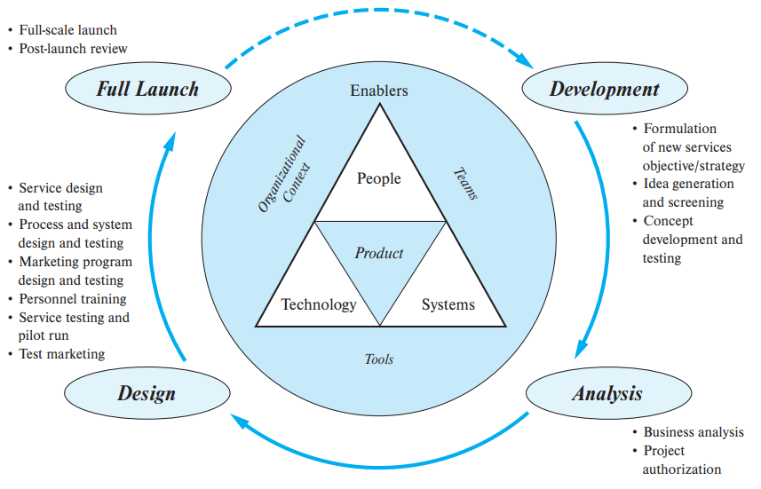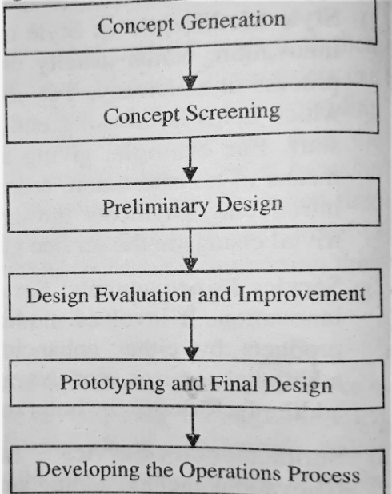

## Illustrate and explain service gap

Service gap is a concept that describes the difference between what customers expect from a service and what they actually receive. It is a measure of the gap between customer expectations and perceptions of service quality.

There are several types of service gaps, including:

1. **Knowledge gap**: This refers to a situation where service providers lack knowledge or understanding of customer needs, expectations, or preferences. This gap can be addressed by conducting market research and gathering customer feedback to better understand customer needs.
2. **Standards gap**: This refers to a situation where service providers fail to set appropriate service standards, or fail to meet the standards they have set. This gap can be addressed by setting clear service standards and implementing quality control measures to ensure that these standards are met.
3. **Delivery gap**: This refers to a situation where service providers fail to deliver the service as promised, or fail to deliver the service in a way that meets customer expectations. This gap can be addressed by improving service delivery processes, training employees to deliver high-quality service, and implementing quality control measures to ensure that service delivery meets customer expectations.
4. **Communication gap**: This refers to a situation where service providers fail to communicate effectively with customers, leading to misunderstandings or unmet expectations. This gap can be addressed by improving communication channels, providing clear and accurate information to customers, and training employees to communicate effectively with customers.
5. **Perception gap**: This refers to a situation where customers have different perceptions of service quality than service providers. This gap can be addressed by gathering customer feedback, measuring customer satisfaction, and using this information to improve service quality.

## Short note on service competitive strategy

Service competitive strategy is a set of actions that service providers take to gain a competitive advantage over their rivals and achieve their business objectives. This strategy involves a careful analysis of the market, customer needs, and the strengths and weaknesses of the service provider, in order to identify opportunities to differentiate the service and create value for customers.

There are several service competitive strategies that service providers can adopt, including:

1. **Cost leadership**: This strategy involves offering services at a lower cost than competitors, while maintaining a similar level of quality. Service providers can achieve this by optimizing their operations, reducing waste, and streamlining their processes.
2. **Differentiation**: This strategy involves offering unique and differentiated services that stand out from those offered by competitors. Service providers can achieve this by creating innovative services, providing exceptional customer service, or focusing on a particular niche market.
3. **Focus**: This strategy involves targeting a specific market segment or customer group and tailoring services to meet their specific needs. Service providers can achieve this by specializing in a particular type of service or industry, and building a strong reputation within that niche.
4. **Collaboration**: This strategy involves partnering with other companies or organizations to provide complementary services or to create new value for customers. Service providers can achieve this by forming strategic alliances, joint ventures, or partnerships with other companies.

Effective service competitive strategy requires a deep understanding of the market and customer needs, as well as a focus on continuous improvement and innovation. Service providers must also be agile and responsive to changes in the market and customer preferences, in order to remain competitive and drive growth and profitability.

## What are the dimensions of service quality

Service quality can be defined as the overall level of excellence or superiority of a service in meeting the needs and expectations of customers. The dimensions of service quality are the specific factors that customers use to evaluate the quality of a service. These dimensions were first proposed by researchers Parasuraman, Zeithaml, and Berry in the late 1980s and are commonly known as the SERVQUAL model.

The five dimensions of service quality are:

1. **Tangibles**: This refers to the physical appearance of the service, including the facilities, equipment, and appearance of employees. Tangibles can affect customers' perceptions of the reliability and quality of the service.
2. **Reliability**: This refers to the ability of the service provider to deliver the service as promised, accurately and dependably. This includes factors such as promptness, consistency, and the ability to resolve problems or issues.
3. **Responsiveness**: This refers to the willingness of the service provider to help customers and provide prompt service. This includes factors such as the speed of service, the willingness to help, and the ability to adapt to customers' changing needs.
4. **Assurance**: This refers to the trustworthiness, expertise, and competence of the service provider. This includes factors such as the knowledge and skills of employees, the ability to inspire confidence, and the ability to handle customer complaints effectively.
5. **Empathy**: This refers to the ability of the service provider to understand and meet customers' needs and expectations. This includes factors such as personalized attention, listening skills, and the ability to respond to customer feedback.

The dimensions of service quality are important because they help service providers identify areas where they need to improve in order to meet customer needs and expectations. By focusing on these dimensions, service providers can improve the quality of their service and create a more satisfying experience for customers.

## Features of queuing system and what are calling systems

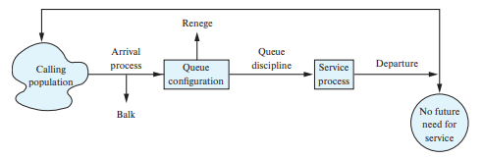

### Calling Population

The calling population need not be homogeneous; it might consist of several subpopulations. For example, arrivals at an outpatient clinic can be divided into walk-in patients, patients with appointments, and emergency patients. Each class of patient places different demands on services, but more important, the waiting expectations of each will differ significantly.

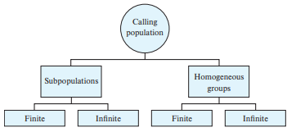

### Arrival Process

Any analysis of a service system must begin with a complete understanding of the temporal and spatial distribution of the demand for that service. Typically, data are collected by recording the actual times of arrivals. These data then are used to calculate interarrival times.

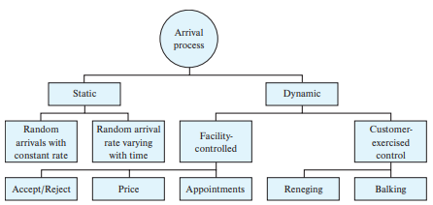

### Queue Configuration

Queue configuration refers to the number of queues, their locations, their spatial requirements, and their effects on customer behaviour.

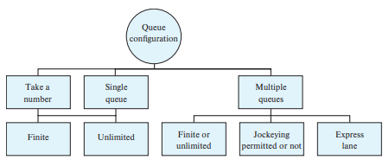

### Queue Discipline

The queue discipline is a policy established by management to select the next customer from the queue for service. The most popular service discipline is the first-come, first-served (FCFS) rule. This represents an egalitarian approach to serving waiting customers, because all customers are treated alike. The rule is considered to be static because no information other than position in line is used to identify the next customer for service.

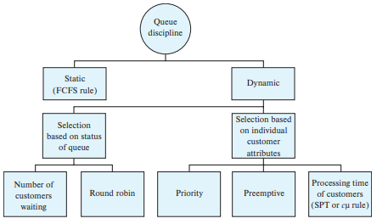

### Service Process

The distribution of service times, arrangement of servers, management policies, and server behaviour all contribute to service performance.

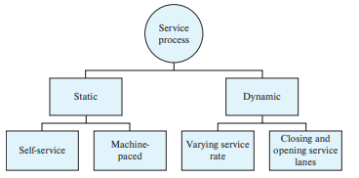

Calling systems are an important aspect of queuing systems, as they help to manage customer flow and provide a more efficient service. Calling systems are designed to alert customers when it is their turn to be served, and there are several types of calling systems, including:

1. **Manual calling systems**: This involves a staff member calling out the names of customers or using a numbering system to indicate when it is their turn to be served.
2. **Electronic calling systems**: This involves the use of technology, such as digital displays, voice announcements or text messages, to notify customers when it is their turn to be served.
3. **Virtual calling systems**: This involves the use of a mobile app or online platform that allows customers to join a virtual queue and receive updates on their place in line and estimated waiting times.

## What are the benefits and disadvantages of outsourcing a service

Outsourcing a service refers to the process of hiring an external service provider to perform certain tasks or functions on behalf of a company or organization. While outsourcing can provide several benefits, it also has some potential drawbacks. Here are some of the benefits and disadvantages of outsourcing a service:

Benefits of outsourcing a service:

1. **Cost savings**: Outsourcing a service can often be more cost-effective than hiring and training in-house staff. This is because the service provider may be able to leverage economies of scale and specialized expertise to offer lower costs.
2. **Access to expertise**: Outsourcing a service can provide access to specialized skills and expertise that may not be available in-house. This can help to improve the quality-of-service delivery and enhance the overall competitiveness of the organization.
3. **Flexibility**: Outsourcing can provide greater flexibility in terms of adjusting staffing levels and service offerings in response to changing business needs and market conditions.
4. **Time savings**: Outsourcing can free up staff time and resources, allowing them to focus on core business functions and strategic initiatives.
5. **Risk management**: Outsourcing can help to mitigate certain risks associated with certain business functions or services, such as data security or regulatory compliance.

Disadvantages of outsourcing a service:

1. **Loss of control**: Outsourcing a service may involve relinquishing some control over the service delivery process, which can be difficult for some organizations to accept.
2. **Quality concerns**: Outsourcing a service can raise concerns about the quality-of-service delivery, especially if the service provider does not have the same level of commitment or understanding of the organization's goals and values.
3. **Communication challenges**: Outsourcing can create communication challenges, especially if the service provider is located in a different geographic region or time zone.
4. **Cultural differences**: Outsourcing to a provider in a different country or region can create cultural differences that may affect service delivery and customer satisfaction.
5. **Security risks**: Outsourcing can create certain security risks, especially if the service provider has access to sensitive data or intellectual property.

## How do you relate service guarantee with organizational effectiveness

A service guarantee is a promise made by a service provider to customers that they will receive a certain level of service quality and satisfaction. When properly implemented, a service guarantee can have a positive impact on organizational effectiveness. Here are some ways that service guarantees can contribute to organizational effectiveness:

1. **Customer satisfaction**: Service guarantees can help to increase customer satisfaction by providing a clear benchmark for service quality and offering recourse if expectations are not met. This can lead to increased customer loyalty and repeat business, which can in turn improve organizational effectiveness.
2. **Employee motivation**: Service guarantees can motivate employees to provide high-quality service by providing a clear goal to work towards and offering incentives for meeting or exceeding customer expectations. This can lead to a more engaged and motivated workforce, which can improve organizational effectiveness.
3. **Continuous improvement**: Service guarantees can provide valuable feedback on areas where service delivery falls short, which can help organizations identify opportunities for improvement and make necessary changes to improve service quality. This can help organizations to stay competitive and adapt to changing customer needs and expectations.
4. **Reputation**: A strong service guarantee can help to build a positive reputation for an organization, which can attract new customers and enhance the organization's overall brand image. This can contribute to organizational effectiveness by improving customer acquisition and retention.
5. **Accountability**: Service guarantees can provide a sense of accountability for service delivery, both internally and externally. This can help to create a culture of responsibility and ownership, which can improve organizational effectiveness by fostering a sense of pride and commitment among employees.

Overall, service guarantees can contribute to organizational effectiveness by improving customer satisfaction and loyalty, motivating employees, promoting continuous improvement, enhancing reputation, and creating a culture of accountability. However, it is important for organizations to carefully design and implement service guarantees to ensure that they are effective and sustainable over the long term.

## Write short notes on service blueprints

Service blueprints are visual tools that allow organizations to map out the various processes and interactions that take place when delivering a service. A service blueprint provides a detailed view of a service and its underlying processes, helping organizations to identify areas for improvement and streamline service delivery.

Service blueprints typically include a number of key elements, such as:

1. **The customer journey**: This includes all the touchpoints that a customer interacts with when using the service, from initial contact through to completion.
2. **Frontstage and backstage processes**: These are the processes that take place in the front of house (where the customer interacts directly with service personnel) and the back of house (where the service is prepared and delivered).
3. **Service support processes**: These are the internal processes that support service delivery, such as scheduling, training, and quality assurance.
4. **Physical evidence**: This includes any tangible elements of the service experience, such as signage, decor, or equipment.
5. **Service personnel**: These are the employees who deliver the service and interact with customers.

The purpose of a service blueprint is to provide a clear and detailed understanding of the service delivery process, which can help organizations to identify areas for improvement and optimize service delivery. By mapping out the various touchpoints and processes involved in delivering a service, organizations can identify bottlenecks, inefficiencies, and opportunities for improvement.

Service blueprints can also be used to communicate the service delivery process to employees, helping them to understand their roles and responsibilities in delivering the service. This can help to ensure that employees are aligned with the organization's service goals and are working together to deliver a high-quality service experience.

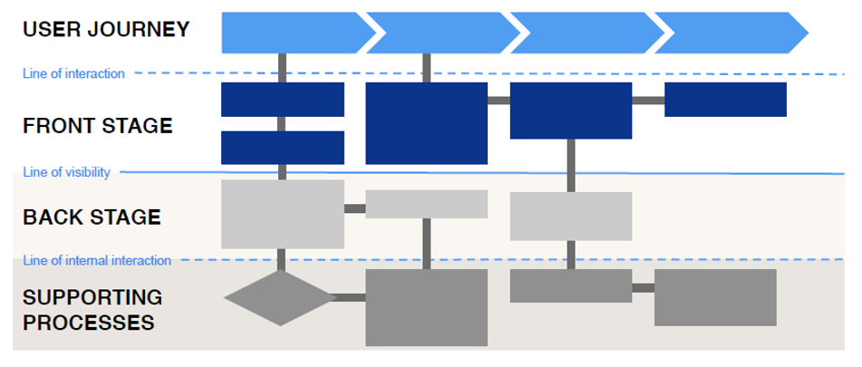

## Explain with example complaint handling policy

A complaint handling policy outlines the procedures that an organization follows when a customer raises a complaint or expresses dissatisfaction with a product or service. A well-designed complaint handling policy is an important aspect of service quality, as it allows organizations to address customer concerns in a timely and effective manner.

Here is an example of a complaint handling policy:

1. **Acknowledgement of complaints**: When a customer submits a complaint, the organization should acknowledge the complaint as soon as possible, typically within 24 hours. The acknowledgement should include an explanation of the organization's complaint handling process and an estimated timeframe for resolution.
2. **Investigation of complaints**: The organization should investigate the complaint thoroughly, including gathering relevant information and speaking with relevant employees or stakeholders. The investigation should be conducted impartially and objectively.
3. **Resolution of complaints**: Once the investigation is complete, the organization should determine an appropriate resolution. This may include offering a refund, providing a replacement product or service, or taking steps to prevent the issue from recurring in the future.
4. **Communication with customers**: The organization should communicate the resolution of the complaint to the customer in a clear and timely manner. The communication should include an explanation of the resolution and any next steps that the customer needs to take.
5. **Feedback and continuous improvement**: The organization should seek feedback from customers on the complaint handling process and use this feedback to continually improve the process.

For example, a hotel might have a complaint handling policy that includes the following procedures:

1. **Acknowledgement**: When a customer submits a complaint about their hotel room, the front desk staff should acknowledge the complaint within 30 minutes and provide an estimated timeframe for resolution.
2. **Investigation**: The hotel should investigate the complaint by speaking with relevant staff, inspecting the room, and reviewing any relevant policies or procedures.
3. **Resolution**: If the complaint is valid, the hotel should take steps to resolve the issue, such as offering a room upgrade, providing a refund, or fixing the problem.
4. **Communication**: The hotel should communicate the resolution to the customer in a timely and clear manner, ensuring that the customer understands the resolution and any next steps.
5. **Feedback**: The hotel should seek feedback from customers on the complaint handling process and use this feedback to continually improve the process, such as by providing additional training to staff or updating policies and procedures.

## What is psychology of waiting

The psychology of waiting refers to the psychological and emotional experiences of people who are waiting for a service or product. Waiting is an inevitable part of daily life, and it can be frustrating, stressful, and boring for people. However, the psychology of waiting suggests that the experience of waiting can be influenced by various factors, including the perceived fairness of the waiting process, the perceived control that people have over their wait, and the perceived value of the service or product that they are waiting for.

Research in the field of psychology has identified several key factors that influence people's experiences of waiting. These include:

1. **Perceived fairness**: People are more likely to accept a wait if they perceive that the process is fair and that everyone is being treated equally. For example, if people are waiting in a queue, they are more likely to accept the wait if they can see that everyone else is also waiting in the same queue.
2. **Perceived control**: People are more likely to tolerate a wait if they feel that they have some control over the situation. For example, if people are given an estimate of how long their wait will be, they may feel more in control and therefore more tolerant of the wait.
3. **Perceived value**: People are more likely to tolerate a wait if they perceive that the service or product, they are waiting for is of high value. For example, people may be willing to wait for hours to get into a popular restaurant because they perceive the food as being of high value.
4. **Anxiety and boredom**: Waiting can also lead to negative emotions such as anxiety and boredom, which can further exacerbate people's negative experiences of waiting.

Understanding the psychology of waiting is important for service providers, as it can help them to design waiting processes that are more acceptable and less frustrating for their customers. By minimizing wait times, providing accurate wait estimates, and creating a fair and organized waiting process, service providers can help to reduce customer anxiety and boredom and create a more positive waiting experience.

## Explain customer journey map

A customer journey map is a tool used to visualize the entire customer experience with a company, product, or service. It provides a detailed view of the touchpoints that a customer has with a business, from the initial awareness stage through to the post-purchase stage. Customer journey mapping helps businesses to understand their customers better and improve their overall experience.

The following are the key components of a customer journey map:

1. **Personas**: A persona is a fictional representation of a typical customer or user. They help businesses to understand the needs, goals, behaviours, and attitudes of their customers.
2. **Touchpoints**: Touchpoints are the moments when a customer interacts with a business. These can be physical, such as a store visit, or digital, such as a website or social media interaction.
3. **Emotions**: Emotions are a critical part of the customer journey, and customer journey maps include emotional states at each touchpoint. Understanding customers' emotional responses can help businesses to tailor their approach and improve the customer experience.
4. **Pain points**: Pain points are the problems or frustrations that customers experience at each touchpoint. By identifying these pain points, businesses can take steps to address them and improve the overall customer experience.
5. **Opportunities**: Opportunities are areas where a business can enhance the customer experience. By identifying these opportunities, businesses can take steps to improve the customer experience and differentiate themselves from competitors.

Creating a customer journey map involves several steps, including:

1. **Identifying customer personas**: This involves creating a detailed description of the target customer, including demographics, behaviours, and preferences.
2. **Mapping touchpoints**: This involves identifying all the touchpoints that a customer has with a business, including physical and digital interactions.
3. **Identifying emotions and pain points**: This involves identifying the emotional states that customers experience at each touchpoint and any pain points they encounter.
4. **Identifying opportunities**: This involves identifying areas where a business can enhance the customer experience and differentiate themselves from competitors.
5. **Analysing and improving**: Once the customer journey map is complete, businesses can analyse the findings and take steps to improve the customer experience at each touchpoint.

Overall, customer journey mapping is a powerful tool for businesses to improve their customer experience and increase customer loyalty. By understanding the needs, preferences, and emotions of their customers, businesses can create a more personalized and engaging customer experience that meets and exceeds their expectations.

## Explain customer package

*The service package is defined as a bundle of goods and services with information that is provided in some environment.*

1. ***Supporting facility***: The physical resources that must be in place before a service can be offered. Examples are a golf course, a ski lift, a hospital, and an airplane.
2. ***Facilitating goods***: The material purchased or consumed by the buyer, or the items provided by the customer. Examples are golf clubs, skis, food items, replacement auto parts, legal documents, and medical supplies.
3. ***Information***: Data that is available from the customer or provider to enable efficient and customized service. Examples include electronic patient medical records, airline showing seats available on a flight, customer preferences from prior visits, GPS website location of customer to dispatch a taxi, and Google map link on a hotel website.
4. ***Explicit services***: The benefits that are readily observable by the senses and that consist of the essential or intrinsic features of the service. Examples are the absence of pain when a tooth is repaired, a smooth-running automobile after a tune-up, and the response time of a fire department.
5. ***Implicit services***: Psychological benefits that the customer may sense only vaguely, or the extrinsic features of the service. Examples are the status of a degree from an Ivy League school, the privacy of a loan office, and worry-free auto repair

A well-designed service package should take into consideration the specific needs and preferences of the target customer segment. The package should provide a unique value proposition that sets it apart from competing offerings in the marketplace. To create a successful service package, businesses should consider factors such as customer needs, preferences, budget, and buying behaviour.

